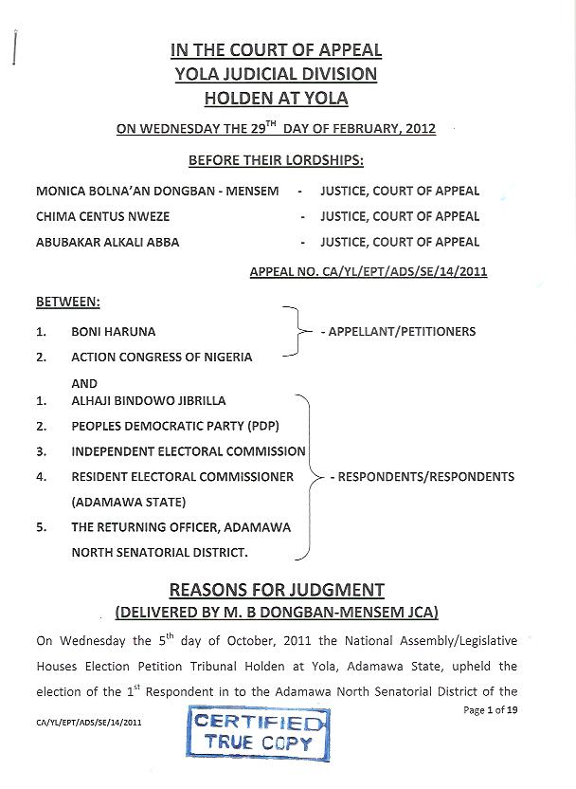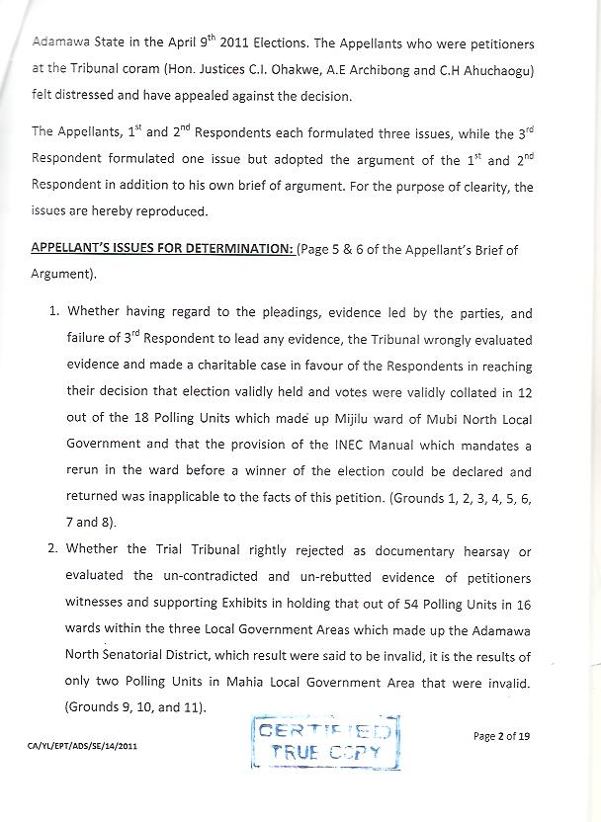 Whether the Trial Tribunal rightly came to a correct and just decision when they held that the correct result of the election was that 1st Respondent won by 75,607 votes to Appellant’s 71,667 votes and rejected the Petitioner/Appellant case that they won the election by majority of lawful valid of 68,135 to Respondent’s 64,909 votes or that in the alternative the alleged non-compliance in the conduct of the election were substantial, and substantially affected the result of the election. (Grounds 12, 13 and 14).
1ST AND 2ND RESPONDENTS’ ISSUES FOR DETERMINATION: (Page 7 of 1st and 2nd Respondent brief of Argument)
- Was the Tribunal right in holding that election was validly held and votes collated in 12 out of the 18 units of Mijilu ward in the Mubi North Local Government Area of the Adamawa North Senatorial District for the said election of 9th day of April, 2011? (Grounds 1,2,3,4,5,6,7, and 8).
- Was the Tribunal right in rejecting the hearsay evidence of the Appellants as to their alleged acts of non-compliance with the Electoral Act, 2010 (as Amended) with respect to the 54 polling units in 16 wards within the 3 Local Government Areas of the Adamawa North Senatorial District? (Grounds 9, 10, 11, and 12).
- Was the Tribunal right in holding that the alleged acts of non-compliance with the Electoral Act, 2010 (as Amended) were unsubstantiated and insubstantial and that the correct result of the election was that the 1st Respondent won the election by 75,607 votes to the 1st Appellant’s 71,667 votes. (Grounds 13 and 14).
3RD RESPONDENT’S ISSUES FOR DETERMINATION: (Page 7 of the 3rd Respondent’s Brief of Argument).
- Whether the Appellant has proved and discharged the burden of establishing non-compliance with the Electoral Act and Corrupt Practices against the election of Adamawa North Senatorial District held on the 9th of April, 2011.
I find the Appellants’ issues rather circuitous. On other hand, the issues which the 1st and 2nd Respondents formulated are more remarkable for their precision and concinnity. All the same, we take the liberty to reformulate them into two issues as follows:
- Whether the Tribunal was right in holding that election was validly held and votes collated in 12 out of the 18 units of Mijilu ward in the Mubi North Senatorial District?
- Whether the Tribunal was right in holding that election held and were conducted in substantial compliance with the Electoral Act, 2010 (as amended) in the 54 polling units in 16 wards within the three Local Government Areas of Adamawa North Senatorial District?
The Appellant had filed an interlocutory appeal from the decision of the Adamawa State National Assembly/Legislative Houses Election Petition Tribunal (Hereinafter called the “Tribunal”) delivered on the 17th day of August, 2011. It suffices to state here that the interlocutory appeal is time-barred as it is caught by Section 9(7) of the Constitution of the Federal Republic of Nigeria (Second Alteration) Act No. 2, 2010.
ISSUE ONE.
The core of the Appellants’ case is that, valid election did not hold nor were valid results collated at the 18 polling stations which make up Mijilu ward in Mubi North Local Government Area in the Adamawa North Senatorial District. That as a result the election was inconclusive. To this end petitioner/appellants pleaded and invoked the provisions of the INEC Manual for the election 2010 which governs the resolution of an election where voting did not take place or was partially cancelled, notwithstanding that voting had taken place in other areas which make up the constituency. (See paragraph 12 (x) of the petition at page 5 of the record. See paragraph 16 (IV) of the adopted written deposition of PW1 at 66 of the record).
The Appellants in their outright condemnation of the Tribunal have deliberately omitted to mention that the Tribunal also voided the elections in 2 polling units (Unit 001 in Mayo Nguli ward and Unit 003 in Ndukwu ward) within this disputed 54 polling units in addition to the 2 units also voided in Mijilu ward based on lack of proper accreditation of the voters registers.
The Respondents on the other hand submit that elections held and results were dully collated. The appellants, argue the Respondents had failed to meet even the minimal/primary stand of proof, that elections did not hold in Mijilu ward. The 1st and 2nd Respondents on their part in proof of the fact that elections actually and duly held in 12 (Twelve) units of Mijilu ward tendered and placed before the Tribunal all the electoral forms and documents used during the conduct of the said election.
The Tribunal, maintains the Respondents was seized of all the electoral materials used for the conduct of elections in the 12 polling units. The learned members of the Tribunal agreed with the submission of the Respondents, found and held in these terms (at page 449 of the records).
“In the instant case we have before us the voters registers in respect of the 18 polling units in Mijilu ward tendered by the petitioners as Exhibits 0.1-0.20 Forms EC8As in respect of 12 polling units in Mijilu ward tendered by the 1st and 2nd Respondents as Exhibits “VV. 1 – “VV.12” copy of Forms EC8B in respect of Mijilu ward tendered by the 1st and 2nd Respondents as Exhibits “UU”, EC8E for Adamawa North Senatorial District were also tendered by the 1st and 2nd Respondents as Exhibits “XX”, “YY.1 – “YY.3” respectively. The 1st and 2nd respondents also tendered Form EC25A to show the receipt and distribution of election materials to presiding officers in Mijilu ward for the election i.e. Exhibits “WW” Form EC40G was tendered by the 1st and 2nd Respondents to show that the elections were cancelled in only six out of 18 polling units in Mijilu ward. It is Exhibits. “XX”.
Apart from the above Exhibits the 1st and 2nd Respondents also tendered the uncontradicted evidence of DW1 and DW2 in proof of their assertion that election actually held in 12 of the 18 polling units in Mijilu ward on 9th April, 2011. Both parties had agreed that election was cancelled in 6 polling units in Mijilu ward and Exhibits “XX” conclusively shows evidence of the cancellation. By this therefore, it is clear that the parties did not join issue in respect of those 6 polling units but the remaining 12 polling units in Mijilu ward.
The tendering of all the above mentioned documents and the evidence of DW1, and DW2, constitute evidence of due compliance with the entire stages of an election from accreditation of voters to voting, to collation of results in all the requisite electoral forms and the declaration of the results in the 12 polling units of Mijilu ward. (See the case of Fayemi v. Oni and Ambare v. Sylva).
The substratum of the evidence of the PW1 is that election held in the said Mijilu ward. This sharply contradicts the outright denial of the appellant that election did not hold at all.
The Respondents submit that the evidence of the PW1 amounts to an admission against interest and I agree. The learned members of the Tribunal thoroughly analysed the case before them in these terms:
The concept of election denotes a process constituting accreditation, voting, collation, recording on all relevant INEC forms and declaration of results. (See Fayemi v. Oni (2007)7 NWLR (Pt. 1222)326 and INEC v. Ray (2004)14 NWLR (Pt. 892)92, 1071-1072. In the case of Amgbare v. Sylva (2009)1 NWLR (Pt. 1121)62, paragraph C-H it was held that the production of the result of the polls counted at the polling units by the presiding officers and recorded in form EC8A is an essential element of the burden of proof that there was an election, that polling booths or units are at the root or base of the pyramid of the whole electoral process. It is only by infere4nce to Form EC8A that the authentic figure at the polls will be ascertained. Forms EC8B, EC8C, EC8D, etc are legally authorized to be made by virtue of Sections 74 and 75 of the Electoral Act, 2006 for the step by step recording of the polls by way of electoral forms.
In addition to the above the Court of Appeal in Fayemi v. Oni (2010)97 NWLR (Pt. 1222)326 went further to stress the significance of voters register in proving that there was election. In that case the Court held that the absence of voters register for the wards signifies that there is no proof that the requirement of accreditation was complied with. That it is only the examination of the voters register that would serve to ascertain whether or not accreditation has taken place in a particular polling units. In other wards the filling of form EC8A alone cannot confer validity on an election.
No proof that a valid election took place in Mijilu ward, whoever, asserts that fact, must tender the voters register for that ward as proof that the requirement of accreditation was complied with. He must also tender forms EC8As for the polling units of Mijilu ward to show that votes were cast, counted at the polling units by the presiding officers and recorded accordingly. It is the law that form EC8A is the foundation of any election and form EC25 is the only authentic proof of receipts and distribution of election materials to the presiding officers. (See Amgbare v. Sylva (supra)13.
In this case form EC25 for Mijilu ward must also be tendered to show the receipt and distribution of election materials for the election to the presiding officers in that ward. All the other processes of collation and declaration of result must also be established by tendering forms EC8B, EC8C and EC8D in respect of Mijilu ward. In the instant case we have before us the voters registers in respect of the 18 polling units in Mijilu ward tendered by the Petitioners as Exhibits 0.1-0.20. forms EC8As in respect of 12 polling units in Mijilu ward tendered by the 1st and 2nd Respondents as Exhibits “VV.1”-“VV.12” copy of forms EC8B in respect of Mijilu ward tendered by the 1st and 2nd Respondents as Exhibits “UU”, EC8C for Mubi North Local Government Area and forms EC8D and EC8E for Adamawa North Senatorial District were also tendered by the 1st and 2nd Respondents as Exhibits “XX”, “YY.1”-“YY.3” respectively. The 1st and 2nd Respondents also tendered form EC25A to show the receipt and distribution of election materials to residing officers in Mijilu ward for the election i.e. Exhibits “WW”, form EC40G was tendered by the 1st and 2nd Respondents to show that the elections were cancelled in only six out of 18 polling units in Mijilu ward. It is Exhibits “XX”.
It was further the finding of the Tribunal that the petitioners in paragraph 12 (ii) of the petition pleaded that voting did not take place nor were results returned from any of the polling units in Mijilu ward in Mubi Local Government Area, one of the constituent wards which make up the Adamawa North Senatorial district in respect of which the election was conducted.
To prove the above, the petitioners relied on the evidence of their 4 witnesses and the voters registers in respect of the said 18 polling units. The Tribunal found that none of the 4 witnesses gave any direct eye witness account of what happened at the 18 polling units of Mijilu ward on the 9th of April, 2011 during the National Assembly election in the Adamawa North Senatorial District. None of the 4 witnesses called by the petitioners is either from Mijilu ward nor voted in any of the polling units in Mijilu ward on that day, nor functioned as an agent or observer in any of the said polling units on the material day.
The appellant relied heavily on the evidenced of PW1 which the Tribunal found to have rather supported the case of the Respondents. The learned members of the Tribunal expressed their opinion at page 742 of the record as follows:
“However PW1 considered to be the petitioner star witness admitted under cross-examination that elections held in 12 (twelve) of the 18 polling units in Mijilu ward. All the 4 petitioners’ witnesses said that they were only informed by their agents that election did not take place in the 18 polling units of Mijilu ward on the 9th day of April 2011. PW2 specifically said that the said agents are alive and available but they were not fielded to give direct eyewitness account of what actually happened in those 18 polling units and the fact that election actually did not take place thereat”.
The evidence of the witnesses called by the petitioners are inadmissible to prove the issue of non-voting in Mijilu ward being hearsay evidence. The evidence of PW2, PW3, having been declared as lacking legal evidential value, that of the PW1 has further fatally afflicted the case of the Appellants. That in a desperate attempt to salvage their case, the Appellant fell back on documentary evidence to prove the non-voting or non-holding of valid election in Mijilu ward. In the words of the Tribunal:-
It is for this reason that the petitioners tendered the voters registers in respect of the 18 polling units in Mijilu ward as Exhibits “0” to “0.20” ostensibly to show that there was no accreditation of voters in the said 18 polling units as such there could not have been a valid election held by the 3rd Respondent officials in the said polling units as alleged by the Respondents.
The 1st and 2nd Respondents case is that election did not only hold in Mijilu ward but that it was conducted in substantial compliance with the provisions of the Electoral Act, 2010 (as amended) The following documents were tendered before the Tribunal in substantiation of the Respondents’ argument.
In the case of INEC v. Usman M. Abubakar (2009)8 NWLR (Pt. 1143)259, 294-295, the Court of Appeal captured the essence of eyewitness account in proving the non-holding of election, when it held thus:-
“Apart from PW4 and PW5 who were officials of INEC subpoenaed to produce documents, the three witnesses who testified for the 1st Respondent (Himself inclusive) were not eyewitnesses. The agents of the 1st Respondent or of ANPP at the polling units who supplied information upon which the petition was based were not called. Benjamin Obe, the ANPP collation agent at the district collation centre, Otukpo, who started the confusion that engulfed the centre, was not called to testify. In the absence of the eyewitnesses one wondered the basis upon which the lower tribunal found that the 1st respondent has satisfied the requirement of law as to burden of proof.” (See also Ayogu v. Nnamani (2006)8 NWLR (Pt. 981)160 at 187 and the recent case of Ogboru v. Uduaghan (2011)2 NWLR (Pt. 1232)538 at 595-596.
The essence of the decision of the Tribunal, which appears either misconstrue or found to be in bad taste and therefore ignored by the Appellants is that the evidence of the 4 witnesses called by the petitioners are inadmissible.
That in a desperate attempt to salvage what is left of their petition; the Appellants fell back on documentary evidence. This again, the learned members of the Tribunal found to be inadmissible and declared same as documentary hearsay” as against the solid case built up by the Respondents. The Tribunal again referred to the materials evidence produced by the Respondents as:
Twelve certified true copies of INEC Forms EC8A for the 12 polling units of Mijilu ward to show that votes were cast and scores declared and recorded for the said units, EC8B showing that results from the 12 polling units were collated at the ward level, EC8C evidencing collation of results from Mijilu ward at the local environment level, EC8D for the declaration of results and EC8E to show that the 1st Respondent was duly returned as the winner of the election.
They also tendered a certified true copy of Form EC25A to show that ballot papers were actually issued and distributed by INEC for the election in Mijilu ward on 9th April, 2011 and a certified true copy of Form EC40G clearly stating that elections were cancelled in only 6 (six) out of the 18 polling units in Mijilu ward. The 1st and 2nd Respondents also fielded DW1 and DW2 who testified to the effect that elections actually took place in the 12 polling units in Mijilu ward on 9th April, 2011.
The learned members of the Tribunal correctly found that the evidence of the Respondents outweighed that of the Appellant. I find no good reason to defer from that.
ISSUES TWO AND THREE.
The Appellants had challenged the Tribunal’s ruling on the admissibility of the evidence of PW1, PW2 and PW3. The Tribunal rejected their oral testimony as “testimonial hearsay” and the documents as “documentary hearsay” “The main plank of the Appellants attack of the Tribunal’s position is that the witnesses testified as to what they physically inspected by way of electoral materials. In their view, the charts their witnesses prepared could not be faulted in line with the documentary evidence tendered. We pause here to consider the reasons advanced by the Tribunal for rejecting the said testimonial and documentary evidence. Listen to the Tribunal.
“In PW1’s additional statement and in the statement of PW2, both of them stated their discoveries at the inspection to include different signatures of INEC presiding officers on ballot papers and multiple or identical thumb print impression on ballot papers. They have not shown in their testimonies that they were acquainted with the handwriting of the alleged presiding officers and have not shown that they are experts in any areas of science or art or any field of statistics or in any field of study dealing with electoral documents as to indentify different signatures of presiding officers of INEC and identical thumb print impression on ballot papers. Se sections 61(1) & (2) and 57(1) and (2) of the Evidence Act”.
The Tribunal clearly and fully acknowledged the case made out by the Appellant as petitioners and found that in proof of the alleged anomalies and the resultant effect on the overall result of the election as stated above, the Petitioners tendered Exhibits “A” to “TT” consisting of voters registers, ballot papers, results sheets and electoral forms used in conducting the elections as they relate to the respective polling units, wars and Local Government Area in contention. They also relied on the testimonies of their witnesses, particularly the additional or further statement on Oath of PW1 and the chart in his first statement where in the results of the polling units affected by the alleged anomalies are tabulated and computed. On the allegations of anomalies, that the PW1 in his first statement on Oath stated that it was based on the oral report and duplicate copies of the results sheets he received from his party agents and collation centers representative that he was able to identify the specific polling units and the anomalies committed therein. That is was also based on the same report that he produced the chart in paragraph 7 of his said statement. In his additional statement on oath he said that he took part in the inspection of electoral materials used in the conduct of the election and that the inspection confirmed the anomalies and further revealed other anomalies in some of the polling units and ward in contention. The witness went to listed the discovered anomalies to include non-stamping and signing of ballot papers/result sheets, non-accounting for missing ballot papers, different signatures appearing on some ballot papers, no evidence of voting, non-accreditation of voters and identical thumbprints impression on some ballot papers. That he also discovered that unused ballot papers were not cancelled or crossed nor marked “unused”
After this extensive review, the learned members of the Tribunal rejected the evidence of PW1 as hearsay evidence while the chart thereon constitute documentary hearsay evidence and therefore ascribed no evidential value to either of them. (See Olalomi Industries Ltd. V. Nigeria Industrial Development Bank (2000)17 NWLR (Pt. 795)58 at 84-85 wherein a document was held to amount to documentary hearsay evidence on the grounds that though the witness signed the documents, he cannot vouch for the contents because the data therein stated did not come from his personal knowledge, apart from the contents being speculative.
The further finding of the Tribunal is better expressed in the words of their lordship:
“PW1’s opinion as contained in his additional statement regarding the confirmation of the anomalies by the inspection cannot also be relied upon in the absence of a clear demonstration by credible evidence of such confirmation and how he arrived at such conclusion. This also goes for the opinion of PW2 in his statement.
In PW1’s additional statement and in the statement of PW2, both of them stated their discoveries at the inspection to include different signatures of INEC presiding officers on ballot papers and multiple or identical thumb print impression on ballot papers. They have not shown in their testimonies that they were acquainted with the handwriting of the alleged presiding officers and have not shown that they are experts in any areas of science or art or any field of statistics or in any field of study dealing with electoral documents as to identify different signatures of presiding officers of INEC and identical thumbprint impression on ballot papers. (See Section 61(1) & (2) and 57(1) and (2) of the Evidence Act.
PW3 and PW4 did not fare any better, their testimonies too are not that of their personal observation of the anomalies. They only repeated what they were informed by their party agents and collation center representatives. Theirs is also hearsay evidence and is also accordingly discountenanced.
Having discountenanced the evidence of PW1 – PW4 as regards the Petitioners allegation of irregularities, the chart in the first statement of PW1 and by implication the computation of the results of the units and wards in the said statement, the next question, is, can the Petitioners rely on documentary evidence alone to establish their allegation of non-compliance with the provisions of the Electoral Act, 2010 (as amended)”.
The learned members preferred the submission of the learned SAN for the 1st and 2nd Respondents and held as follows:-
“On this the stance of the learned senior Counsel for the 1st and 2nd Respondents is that documentary evidence cannot serve any useful purpose without oral evidence explaining its essence. Here he cited and relied on the following Judicial Authorities: Eze v. Okoloagu (2010)3 NWLR (Pt. 1180)183 at 210-211, Abubakar v. Yar’adua (2008)19 NWLR (Pt. 1120)1 at 173-174.
Our understanding of the principles in the above listed cases is not that documentary evidence cannot be relied upon is appropriate cases to proved a fact (s) in issue in a petition. See the case of Fayemi v. Oni (2009)7 NWLR (Pt. 114)223 at 291 paragraph C, where the Court of Appeal held: “That the Tribunal is right to place a greater value on documentary evidence than on oral testimony”. The position of the law is that the most reliable, if not the best evidence is documentary evidence. it is certainly more reliable than oral evidence. (See Akinbisade v. the State (2006)17 NWLR (Pt. 1007)184 and Akike v. Idowu (2006)9 NWLR (Pt. 084)47 at 65.
It is my humble opinion that the learned members got the relevant principle of law right and correctly applied same to the facts placed before them. I am unable to decipher any perversity in the decision of the Tribunal.
The learned Counsel for the Appellant was so irked with the decision of the Tribunal that Counsel expended so much energy depreciating the learned members rather than pay quality time to the issues to be addressed. He got lost in the mast of anger he built up. The learned members of the Tribunal are right in their decision and I have deliberately quoted their decision in extenso, to display the industry they applied and the systematic approach their lordships adopted in the exercise of their onerous duty and thereby also disclosed their experience and dexterity in the law.
Their lordships found and rightly held that the Appellants as Petitioners placed undue reliance on hearsay, oral and documentary evidence. The witnesses merely collated and relayed what they were told by the different agents at the polling units. As to the documents and the charts made and relied upon, no foundation was led as to the competence of the witnesses who analysed the said documents as to skill or even opportunity of working with the INEC officers to be able to identify the signatures in question on basis of familiarity, if such is acceptable in law.
The initial evidential burden never shifts except by the adduction of weighty evidence. We have shown by the decision of the apex Court that where the initial burden does not shift, the Respondent who has been dragged to court has no duty to adduce evidence to strengthen the case of the accuser. The Respondent is however allowed to tap from the minimal evidence of the initiator of the process, to build up his own case. (Refer to Adelakun vs. Oruku (2006)11 NWLR (992)625 at 649. (See also Omotosho vs. Bank of the North (2006)8 NWLR (986)573 at 591, Harka vs. Keazor 92006)1 NWLR (960) 160 at 187 para C-F. also in the case of Ashiru vs. Olukogu (2006) 11 NWLR (990) 1 at 32 SC).
When a Petitioner takes on a petition after an election, often they seem to forget that they take up an institution, in whose favour, there already exists a presumption of regularity. The maxim in Latin is Omnia Preasumantur Rite Esse Acta which means all things are presumed to have been correctly done. Buhari v. Obasanjo (2005)13 NWLR (Pt. 941). Thus, unless a clear foundation with positive assertion is set out with clear evidence of non-performance and the massive non –compliance, the Petitioner has an uphill task. Credible witnesses must be produced who saw and perceived all the incidents of non-compliance, anomalities and irregularities complained of. It is no legal evidence worthy of being acted upon to say that some one told you about what happened at a polling unit. If his story is worthy of belief, why does he not come up and withstand the rigous of cross-examinations?
Indeed, I find it very difficult to understand why the Appellant did not deem it absolutely necessary to field in eye-witnesses to testify as to what they saw and perceived at the polling units? Each witness the Appellant called crumbled under 